Tab 2

STANDARD OPERATING
PROCEDURE (SOP)

Core Fee Orders / Quotes

Department | Sales
Version | 1.1
Effective Date | TBD
Prepared By | Audit Team
Reviewed & Approved By | Justin Bennett

1. What Is a Core Fee?

A core fee is a refundable deposit charged in addition to the product price.
It exists to ensure the customer returns the used or old part (core) after receiving the new item.
No return = No refund.
Return confirmed = Full refund of the core fee with taxes applied on it.

2. Core Fee Rules (Non-Negotiable)
These rules are absolute. No exceptions.
- Core fee is mandatory NOT optional
- Core fee is refundable, but never automatic
- Core fee cannot be discounted
- Coupons cannot be applied to core fees
- Core fee must always be added manually
- Core fee must always appear as a separate line item
- Core fee must have the same cost and unit price
- Core fee must be added for the same quantity
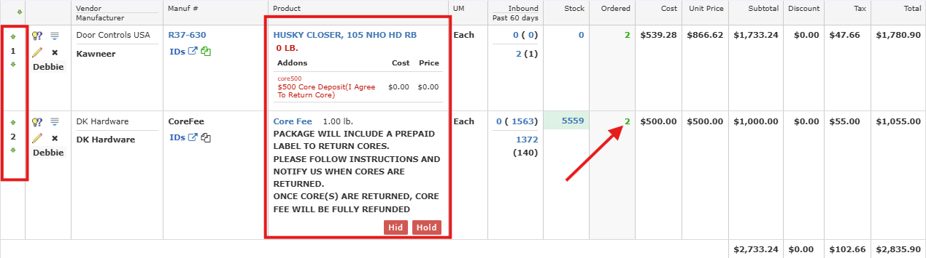
If any of these rules are broken, the order is non-compliant.

3. Pre-Sale Compliance (Before You Place the Order)

Step 1: Product Verification
Before quoting or placing the order, confirm:
- The SKU is flagged as “Core Fee Applicable”
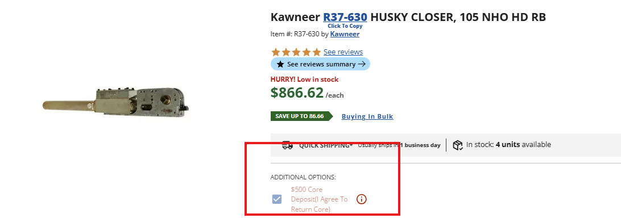
- The core fee amount matches exactly what is listed for that SKU
- You understand what part must be returned as the core
If the SKU shows a core fee and it’s missing from your quote — STOP. Fix it before proceeding.

Step 2: Mandatory Customer Disclosure (You Must Say This)
The customer must clearly understand all of the following before checkout:
You must communicate:
- Item price
- Core fee amount (clearly stated as separate)
- That the core fee is refundable only after return
- That customer is responsible for returning the core
- That a prepaid return label will be provided
There is no shortcut here. If the customer later disputes the fee and this wasn’t disclosed, the company loses.

Step 3: Documentation (Required for Audit Protection)
You must document proof of disclosure using at least one of the following (preferably more):
- Call notes summary
- Email confirmation copy
- Chat transcript
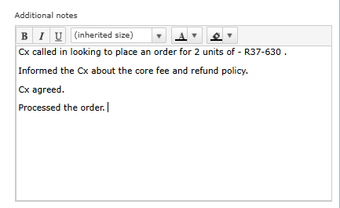
If it’s not documented, it’s considered not disclosed.

4. Order Entry Standards (Critical Section)

4.1 Quote / Order Structure
Every compliant order must look like this:
Line 1: Product price
Line 2: Core fee (separate line item)

4.2 Mandatory Core Fee Description (Must Be Copied Exactly)
The core fee line item must include this description:
“PACKAGE WILL INCLUDE A PREPAID LABEL TO RETURN CORES.
PLEASE FOLLOW INSTRUCTIONS AND NOTIFY US WHEN CORES ARE RETURNED.
ONCE CORE(S) ARE RETURNED, CORE FEE WILL BE FULLY REFUNDED.”
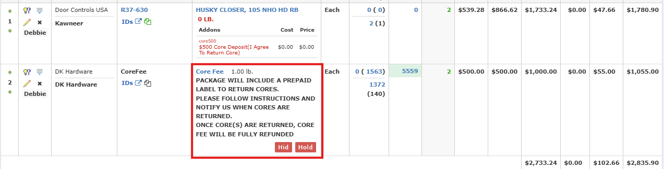
Do not paraphrase. Do not shorten. This protects DKHardware.

5. Strict Prohibitions (Do NOT Do This)
These actions are compliance violations:
- Bundling core fee with item price
- Discounting the core fee
- Applying coupons to the core fee
- Hiding or failing to disclose the core fee
- Assuming refunds are automatic
Any of the above can lead to refund losses, chargebacks, or audit failure.

6. Post-Sale Core Refund Flow (For Awareness)
- Customer receives product
- Create prepaid return label -> Justin / Marina
- Customer ships back the core
- Core fee refund is manually processed
No return = no refund
6.1 POST SALE GUIDE
- Confirm the delivery from BO / Customer
Where - Click on the tracking and see if the item is delivered.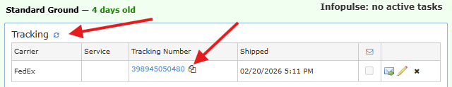
- If the item is delivered, create the return label
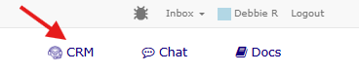
Where - Create task for Justin / Marina toichkina on on CRM
Step 1 - Go to CRM

Step 2 - Click on “Add issue” 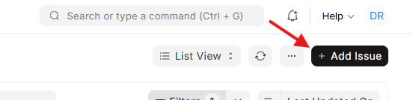
Step 3 - Fill the details accurately and save it 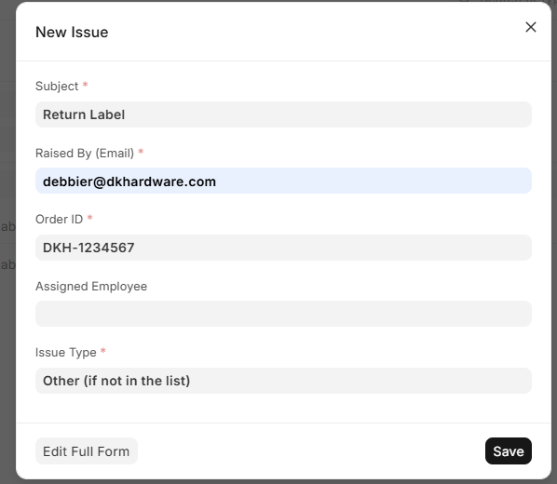

Step 4 - The issue will reflect under in your homepage. Click on it.
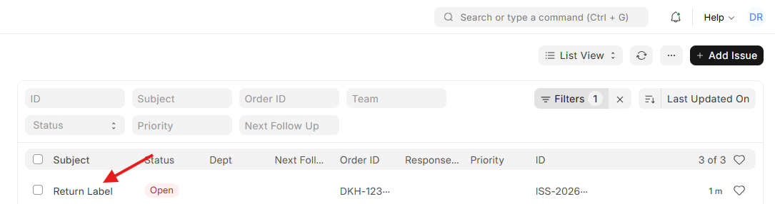

Step 5 - After opening the issue , create a task for Justin / Marina Toichkina, click on the ‘ + ‘
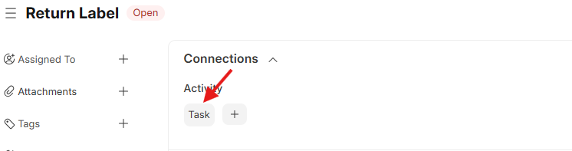
Step 6 - After clicking on the ‘+’ , a pop up will appear asking for the subject. Put the subject and save it.
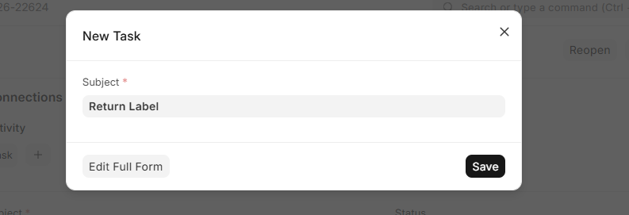

Step 7 - After the subject is saved , the task is created. Now you just have to assign it. On the same page , on the left top corner you will see options like ‘assigned to’ , click on that and put the email of the person - jbennett@dkhardware.com / marinat@dkhardwaresupply.com and click on “Add” . This step saves the work and notifies the person to get the task done.

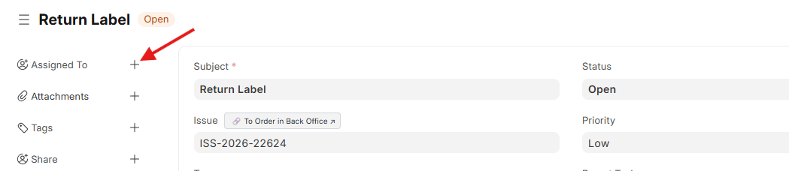

- When the core is returned , it will be mentioned in the notes of the order or in the tracking that says ‘Core Return’
- Once we see the Core return tracking shows ‘Delivered’ , we will process the refund.

For refund , follow the below process:

- Message Justin on Gchat /
- Go to the same task that was created for the return label and put a comment in there for Justin to process the refund.

Points to remember:

- Always inform the customer that it takes 5-7 business days for us to refund the core deposit once the core is successfully returned to us.
- The ideal core return timeline is within 30 calendar days of the shipment delivery.
- The customer needs to be contacted immediately or a day after the shipment is delivered.
- When the return label is created , it is ALWAYS attached to the order under the “Additional Order Information”. You download it, and share it to the customer via Email

7. Quick Compliance Checklist (Before You Hit “Place Order”)
Ask yourself:
- Is the SKU confirmed as core-fee applicable?
- Is the core fee added manually?
- Is it a separate line item?
- Did I disclose the refund condition clearly?
- Is documentation saved?
If the answer to any is no, fix it first.

Final Note
- Core fees are not optional, not flexible, and not customer-negotiated.
- Handled correctly, they protect both DKHardware and the customer.
- Handled casually, they create disputes, losses, and escalations.
Keep a close follow-up on each and every core fee related orders and when delivered, reach out to Justin / Marina Toichkina
Follow the process every time—and you’ll never have an issue.

